



­

Assignment Document:

Entity Framework – Practice Case Study

Cognizant

500 Glen Pointe Center West

Teaneck, NJ 07666

Ph: 201-801-0233  
[www.cognizant.com](http://www.cognizant.com)

## 

Contents

Section A: Business Requirement 3

Section A - API Technical Specifications: 8

## Section A: Business Requirement

TRICARE holiday is leading company which offers trips for customers. The company was manually tracking the details of the customers and now they want to develop a database for tracking the details. They also need information related to customers for reporting purpose.

Now we are going to design the database and get the required information for the company.

**Requirement 1:**

**Create the below Entities using Code First model.**

Create the Users, Shipments and Addresses Entity. Use **Fluent API** to configure the class.

|  |  |  |  |  |
| --- | --- | --- | --- | --- |
| **Table Name** | **Column name** | **Type** | **Nullable** | **Key** |
| **Users** | UserId | Int | No | **Primary Key : UserId**  **Identity : UserId** |
| FirstName | String | Yes |
| LastName | String | Yes |

|  |  |  |  |  |
| --- | --- | --- | --- | --- |
| **Table Name** | **Column name** | **Type** | **Nullable** | **Key** |
| **Shipments** | ShipmentId | Int | No | **Primary Key : ShipmentId** |
| CreatedOn | DateTime | No |
| State | String | Yes |

|  |  |  |  |  |
| --- | --- | --- | --- | --- |
| **Table Name** | **Column name** | **Type** | **Nullable** | **Key** |
| **Addresses** | AddressId | Int | No | **Primary Key : AddressId** |
| Street | String | Yes |
| City | String | Yes |
| PostalCode | String | Yes |

**Database Diagram:**

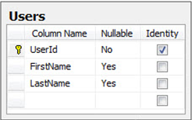

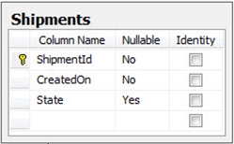

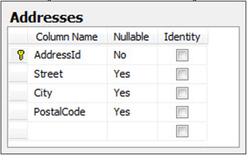

**Requirement 2:**

Now database initialization has to be done. Create the database as per the connection string name from app.config file.

We need to seed the User Entity with initial data. Use **DropCreateDatabaseIfModelChanges** initialization strategy.

Data’s to be inserted:

|  |  |  |
| --- | --- | --- |
| **UserId** | **First Name** | **Last Name** |
| 1 | Sam | S |
| 2 | John | D |
| 3 | Dave | J |
| 4 | Dim | M |

After inserting the values, Write an EnitySQL query to select the count of FirstName where FirstName begins with “D” and display it in console window.

**Sample Output:**

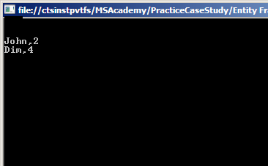

**Requirement 3:**

**Requirement 3a: Adding data**

Add new Addresses and save the changes in the database. Do the changes in operation.cs page

Data’s to be inserted:

|  |  |  |  |
| --- | --- | --- | --- |
| **Address ID** | **Street** | **City** | **PostalCode** |
| 1 | YoungSt | Toronto |  |
| 2 | ThomsonSt | Newyork | 506000 |
| 3 | JohnsonSt | Chicago | 390043 |
| 4 | JamesSt | Newjersy |  |

**Requirement 3b: Adding data**

LastName of John is inserted wrongly. Update the LastName as “A”. Do the changes in operation.cs page

**Requirement 3c: Deleting Data**

We have wrongly inserted UserId- 1 in User Context. Delete UserId 1 from the database. Do the changes in operation.cs page

**Requirement 4:**

Now for reporting purpose we are going to get the required details for the company.

In SQL Server Management Studio open the below script and press F5.



Note: If the entities are not created properly with the specifications given the above script will throw error.

**Requirement 4a:**

You have GetContactId stored procedure in the database. Execute the procedure by passing the parameter value as 1 and print First Name, Last Name and Title in the console window. Do the necessary changes in ReportQuery.cs.

**Requirement 4b:**

Get the number of Address in the Address entity and display it in the console window. Use LINQ to Entities to perform the above action. Do the necessary changes in ReportQuery.cs.

**Requirement 4c:**

Select all Users from Users Table and order by their FirstName in descending order and display it in the console window.. Use LINQ to Entities to perform the above action.

## Section A - API Technical Specifications:

|  |  |  |
| --- | --- | --- |
| **Class Library\Console Application** | **Class Name** | **Method Name** |
| EntityTables | User |  |
| Address |  |
| Shipment |  |
| DatabaseLayer | EntityMappingContext | OnModelCreating() |
| UserContext |  |
| CodeFirst_EmployeeModel | MainCall |  |
| Operations | AddEntity()  Add1Entity()  DeleteEntity() |
| ReportQuery | StoredProcedure()  AddCount()  UserOrderby() |
| SeedUser | AddUserValue() |

**Class Description: User**

Add the User

**Class Description: Address**

Add the user address details

**Class Description: Shipment**

Add the shipment details

**Class Description: EntityMappingContext**

Create the context for the entities created

**Class Description: UserContext**

Create the seed method for User

**Method Description: Seed ()**

Seed the values for users using the seed method.

**Note:-**

* DO NOT ALTER the METHOD SIGNATURES in the code template.
* Do not hardcode the connection string or file names anywhere in the code. Use the existing variable names.